**How do organisms use energy?**[1]

**1a**. Why does your body need energy?

**1b.** How does your body get energy?

Your body’s cells need a constant supply of energy for movement, synthesizing molecules, and other cellular processes. To supply the energy for these processes, your body uses the following steps.

* First, you eat and your food is digested to small organic molecules like glucose which travel in your blood to all the cells in your body.
* Next, your cells use glucose or other small organic molecules as input for a process that provides the energy to make ATP.
* Then, your cells use ATP to provide the energy for cellular processes.

Making ATP

In cellular respiration, glucose or another small organic molecule is one input for reactions that provide the energy to make ATP.

|  |
| --- |
|  |

**2a.** Give one reason why energy input is needed to combine ADP and P to make ATP. (Hint: Examine the figure above.)

**2b.** When ADP and P are combined to make ATP, what additional molecule is also produced?

Using ATP

The hydrolysis of ATP is basically the reverse of the reaction that makes ATP. When ATP reacts with water to produce ADP + P, energy is released. This provides the energy that is needed for many cellular processes such as synthesizing molecules and muscle contraction.

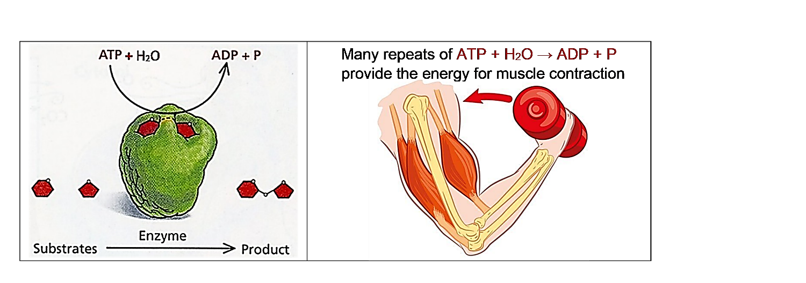

|  |  |
| --- | --- |
| **3a.** Inside each cell, there is a constant cycle of making ATP and hydrolysis of ATP. Add to this diagram to show:   * the source of energy to make ATP; * how the hydrolysis of ATP is useful. |  |

**3b.** Why does a cell need to constantly break down ATP to ADP + P and then remake ATP?

**Cellular respiration makes ATP.**

|  |  |
| --- | --- |
| These chemical equations summarize the process of cellular respiration of glucose. The top chemical equation summarizes complex reactions that provide the energy to make ATP. The curved arrows represent the transfer of |  |

energy from these reactions to multiple repeats of the reaction that makes ATP.

**4a**. Write the names of each molecule in the top chemical equation.

**4b.** Circle the chemical reaction that requires energy input.

**4c.** This pair of chemical equations shows that cellular respiration of a single molecule of glucose provides enough energy to make about _____ molecules of ATP.

**5**. Why do we need to breathe all day and all night?

**6**. How do the cells in your body get glucose for cellular respiration?

**7.** If you search for "cellular respiration equation" on the web, some of the most popular sites give the following chemical equation for cellular respiration of glucose.

C6H12O6 + 6 O2  6 CO2 + 6 H2O + ATP

What is wrong with this chemical equation? (Hint: Think about where the atoms in an ATP molecule come from.)

**Using ATP to Provide Energy for Biological Processes**

The hydrolysis of ATP provides the energy for many biological processes. For example, the hydrolysis of a molecule of ATP provides the energy for a muscle protein to change shape and shorten the muscle a tiny bit. Many many repeats of these reactions result in muscle contraction.

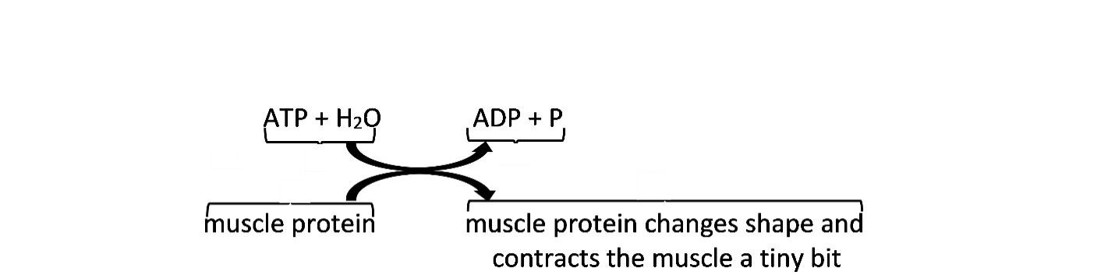

**8a.** What do the curved arrows in this figure represent?

**8b.** Explain why the top reaction is called the hydrolysis of ATP. (Hint: Hydro means water and

the suffix, -lysis, means breaking down or separating.)

**9a.** The hydrolysis of ATP occurs:

in all the cells in your body___ only in muscle cells ___

**9b.** Explain the reasoning that supports your answer to question 9a.

Two important general principles about energy are:

* Energy can*not* be created or destroyed (in biological processes).
* Whenever energy is transformed or transferred, some energy is transformed to thermal energy. (For example, when a muscle contracts, only about 20-25% of the energy released by the hydrolysis of ATP is transformed to the kinetic energy of muscle contraction and the rest is transformed to thermal energy.)

**10a.** During cellular respiration, most of the ATP production takes place in organelles called mitochondria. Some textbooks claim that "Mitochondria make the energy needed for biological processes." What is wrong with this claim?

**10b**. Revise the sentence to be more accurate.

**11.** Explain why your body gets warmer when you are physically active.

1. By Dr. Ingrid Waldron, Univ Pennsylvania, © 2024. This Student Handout (including a Google Docs version) and Teacher Notes (with instructional suggestions and background information) are available at <https://serendipstudio.org/exchange/bioactivities/energy>.